Project Overview
This project analyzes customer shopping behavior using transactional data from 3,900 purchases across various product categories. The goal is to uncover insights into spending patterns, customer segments, product preferences, and subscription behavior to guide strategic business decisions.

SELECT* FROM customer_purchase
---1.Revenue Analysis
---Compare total revenue generated by male and female customers
select gender,sum(purchase_amount)AS total_revenue
from customer_purchase
group by gender
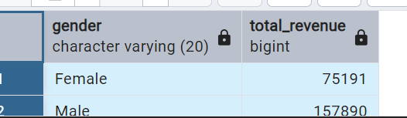
---2.Discount & spending Analyis
---Identify discount users whose purchase amounts were at or above the overall average.
select customer_id,purchase_amount
from customer_purchase
where discount_applied='Yes'
AND
purchase_amount>=(select avg(purchase_amount) from customer_purchase)
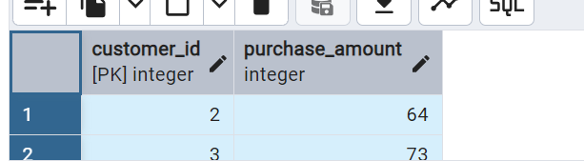

----3 Product Rating Analysis
---Rank the top 5 products by average review rating
select item_purchased,
round(avg(review_rating)::numeric, 2)AS average_review
from customer_purchase
group by item_purchased
order by Average_review desc
limit 5
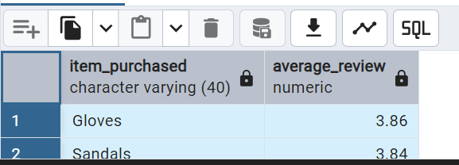

---4 Shipping Analysis
---Compare average purchase amount for standard and express shipping
select shipping_type,round(avg(purchase_amount),2) AS avg_purchase
from customer_purchase
where shipping_type in('Standard','Express')
group by shipping_type
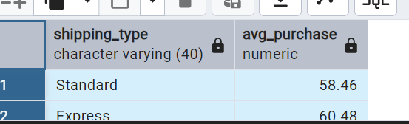

----5 subscription analysis
----Compare customer counts,average spending, and total revenue between
---subscribers and non_subscribers
select count(distinct customer_id)AS total_customers,round(avg(purchase_amount),2)AS avg_spending,
round(sum(purchase_amount),2) AS total_revenue,subscription_status
from customer_purchase
group by subscription_status
order by total_revenue,avg_spending
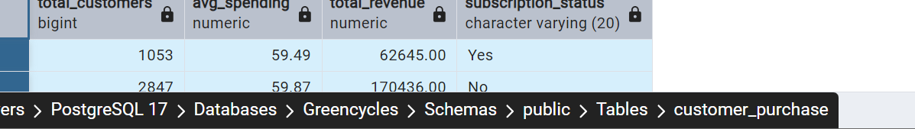

----6 Discount Dependency Analysis
---Identify the top 5 products by percentage of purchases with discounts applied.
select item_purchased,
round(100*sum(case
when discount_applied='Yes' THEN 1
ELSE 0
end )/count(*),2) AS discount_rate
from customer_purchase
group by item_purchased
order by discount_rate desc
limit 5
---7 customer segmentation
----clasify customer into New,Returning,and Loyal segments based on previous purchase
with customer_type as
(select customer_id,previous_purchases,
CASE
when previous_purchases=1 THEN 'New'
when previous_purchases between 2 AND 10 THEN 'Returning'
else 'Loyal'
end AS customer_segment
from customer_purchase)
select customer_segment,count(*)AS customer_numbers
from customer_type
group by customer_segment
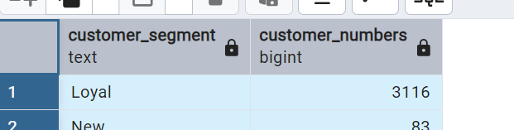

---8 product popularity analysis
---Identify the top 3 most purchased products within each category

with item_count as
(
select category,item_purchased,count(customer_id)AS total_orders,
row_number()over(partition by category order by count(customer_id) desc) AS item_rank
from customer_purchase
group by category,item_purchased)
select category,item_purchased,total_orders,item_rank
from item_count
where item_rank<=3
order by total_orders desc
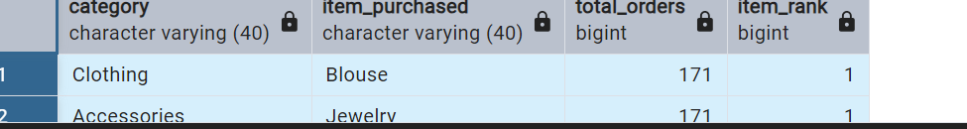

---9 Repeat Buyer Analysis
---Compare subscription status among customers with more than 5 previous purchases
select subscription_status,count(customer_id) AS repeated_buyers
from customer_purchase
where previous_purchases>5
group by subscription_status

--10 Age Group Revenue Analysis
-- Compare total revenue across age
select age_group,sum(Purchase_amount) AS Total_Revenue
from customer_purchase
group by age_group
order by Total_Revenue desc


Business Recommendations
- Grow Subscriptions – Test clear member benefits, such as exclusive offers or early access, and track subscription rate, repeat purchases, and revenue per customer.
- Strengthen Customer Loyalty – Use the New, Returning, and Loyal segments to tailor follow-ups and rewards; monitor repeat-purchase rate and time between purchases.
Optimize Discount Strategy – Identify products frequently bought with discounts, then compare sales and profit to avoid unnecessary markdowns.
Product Positioning – Promote products that combine strong sales with high ratings and investigate lower-rated products before increasing promotion.
Refine Targeted Marketing – Use age-group, category, and gender views to design campaign tests; compare conversion, average order value, and profit before shifting budget



